Rizki Banyu Firdaus  
XII RPL 3

**Database Model**

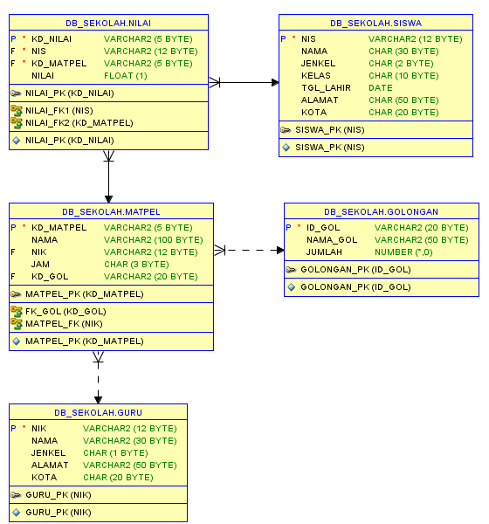

**Trigger TAMBAH_JUM_GOL**

create or replace TRIGGER TAMBAH_JUM_GOL

AFTER DELETE OR INSERT OR UPDATE OF JAM,KD_GOL,KD_MATPEL,NAMA,NIK ON MATPEL

REFERENCING OLD AS DULU NEW AS BARU

FOR EACH ROW

BEGIN

IF INSERTING THEN

UPDATE GOLONGAN

SET jumlah = jumlah + 1

WHERE ID_GOL = :BARU.KD_GOL;

END IF;

IF DELETING THEN

UPDATE GOLONGAN

SET jumlah = jumlah - 1

WHERE ID_GOL = :BARU.KD_GOL;

END IF;

IF UPDATING THEN

UPDATE GOLONGAN

SET jumlah = jumlah + 1

WHERE ID_GOL = :BARU.KD_GOL;

UPDATE GOLONGAN

SET jumlah = jumlah - 1

WHERE ID_GOL = :DULU.KD_GOL;

END IF;

END;

**Data awal T_GOLONGAN**

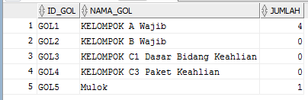

**Menambahkan 1 row pada T_MATPEL**



**Data akhir T_GOLONGAN**

